Chapter 3, Problem 72.

By inspection, write the mesh-current equations for the circuit in Fig. 3.116.

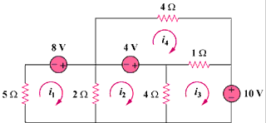

Figure 3.116
For Prob. 3.72.

